IGNATIAN RETREAT:
The Gift of Spiritual Intimacy

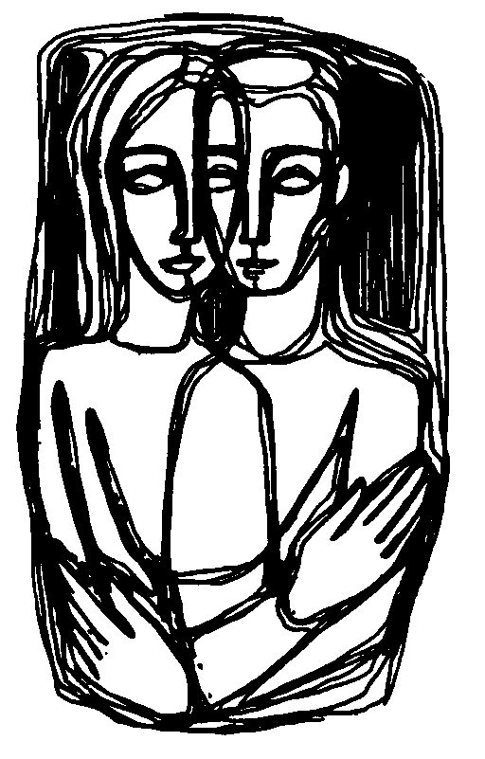
Presented by:
Ingrid Honoré-Lallande, CSJ, M.Div., and Loyola Institute for Spirituality

Friday, July 13, 7:00 p.m. –
Sunday, July 22, 2012, 10:00 a.m.

Aware that God is the Passionate one who desires us and for whom every fiber of our being reaches out, we discover ourselves in an even deeper relationship of lived intimacy with God in the world. This 8-day silent retreat incorporating the dynamics of the Spiritual Exercises of St. Ignatius of Loyola offers participants time for personal prayer, reflection and daily spiritual direction. For more information please contact Ingrid Honoré-Lallande, CSJ at Sr.Ingrid.Honore-Lallande@csjorange.org or 714-744-3175 ext 4428.

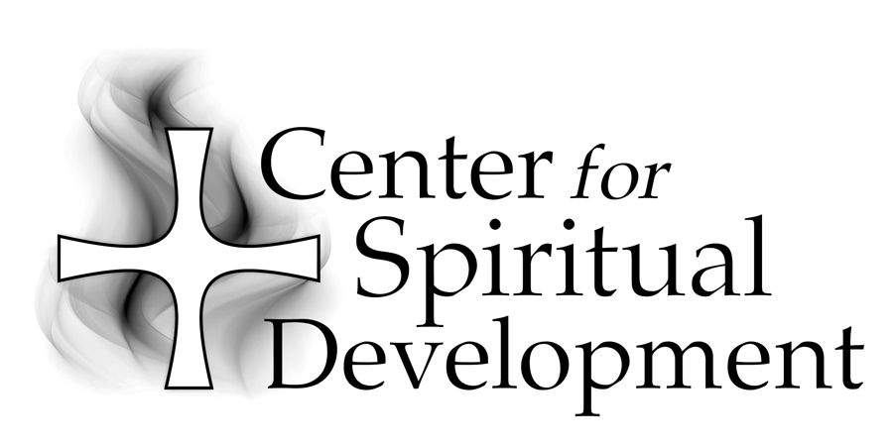
Location: Center for Spiritual Development
434 South Batavia Street
Orange, CA 92868

CSD is located next to St. Joseph Hospital near the corner of LaVeta and Main in the City of Orange.

Fee: $575

To Register:
Please call (714) 744-3175, x4409 or e-mail
gscharff@csjorange.org.

Sponsored by:

A Ministry of the Sisters of St. Joseph of Orange
434 South Batavia Street
Orange, CA 92868-3907

Phone:(714) 744-3175
Fax:(714) 744-3176
E-mail:csdinfo@csjorange.org
Web:www.thecsd.com

Ingrid Honoré-Lallande, CSJ (Carondelet), M.Div., has a BA degree from Mount St. Mary’s College Los Angeles, a Master of Arts degree in Educational Administration from St. Mary’s College of California in Moraga, a Master of Divinity degree from the Jesuit School of Theology at Berkeley and a diploma in the Practice of Giving the Spiritual Exercises and Spiritual Direction from Regis College (University of Toronto) / Loyola House (Guelph, Ontario, Canada). Her special interests include the person of Jesus, the Spiritual Exercises of St. Ignatius of Loyola, teaching, spiritual direction and a variety of crafting projects.

